**JAYPEE UNIVERSITY OF ENGINEERING & TECHNOLOGY** Accredited with Grade-A+ by NAAC & Approved U/S 2(f) of the UGC Act,1956 A.B. Road, Raghogarh, District Guna (MP), India, Pin-473226 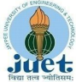

Phone: 07544 267051, 267310-14, Fax: 07544 267011

Website: www.juet.ac.in

**Weekly Progress Report**

**Week No. __4__**

Name: Sapeksh Pareek Enrolment No. 211B274 . Period: 10/06/2024 to 16/06/2024 . Work done during Week (in detail)

During this week of my internship, I focused on upgrading the scraper tool to extract data directly from profiles on the specified social media platform. I enhanced the Selenium-based scraper to navigate profiles efficiently and extract relevant information. This involved refining the scraping logic to handle profile-specific data fields, ensuring accuracy and reliability in data extraction. Additionally, I optimized the API developed in Flask to accommodate profile data retrieval requests, maintaining seamless integration with the existing infrastructure deployed on Vercel. This project further deepened my proficiency in web scraping techniques and backend development using Flask and Selenium.____________________________

Section/Department of Organization (Under which training is going on)

Create a complete landing page website for marketing a specific app, using MUI concepts. Write multiple versions of the HERO section for A/B testing and develop a blogs page with SEO-optimized content._________________

Name of Supervisor: Ms. Anahita Zahl Tantra (HR, Yardstick)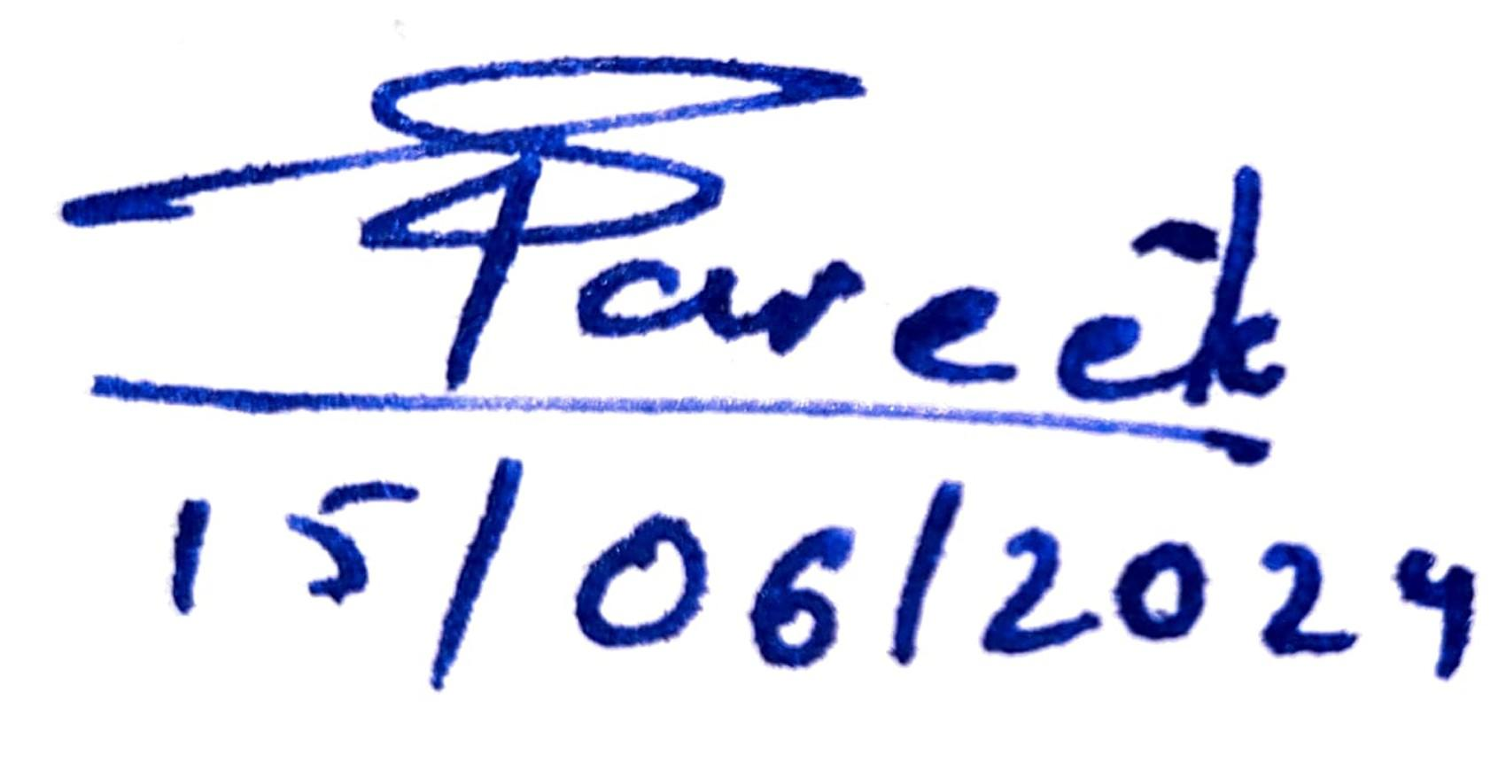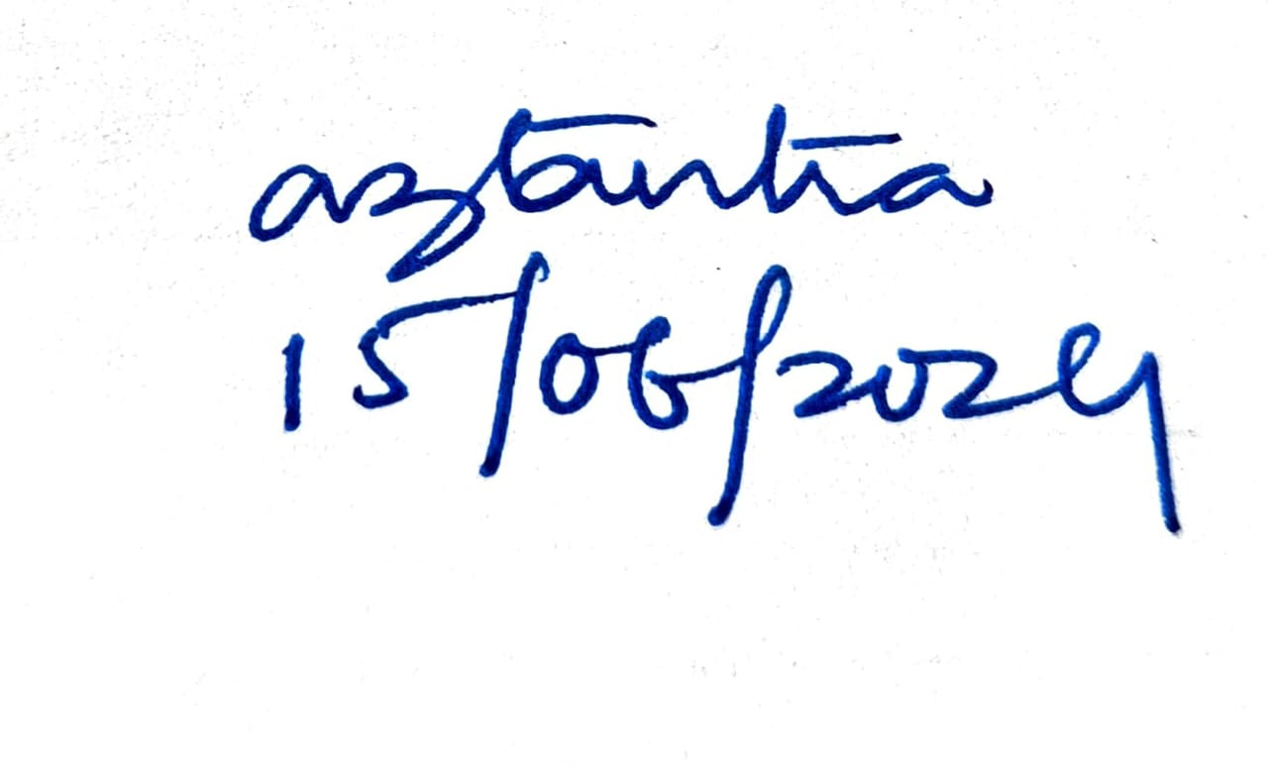

**Signature of Supervisor Signature of Student  
(with date) (with date)**